FINANCIAL ASSISTANCE FORM
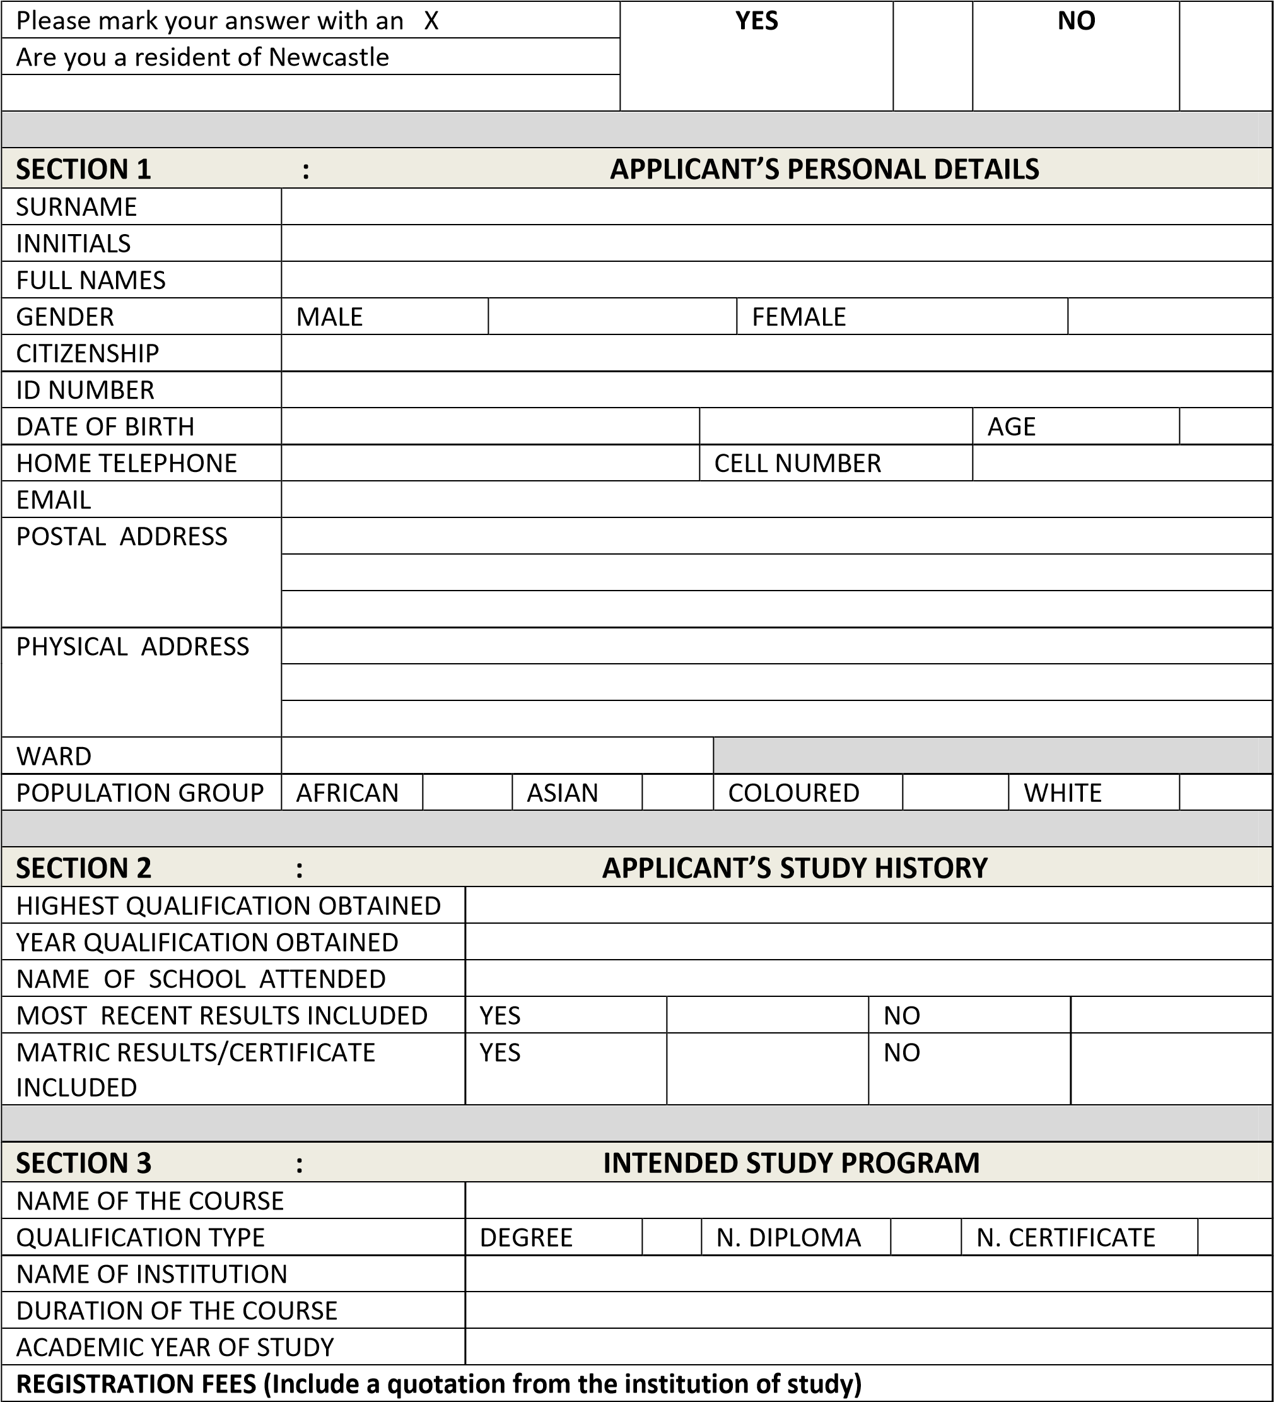

SECTION 4 : ESSAY
(Write an essay of about 250 words or more to motivate your application)

SECTION 5 : PARENT / GUARDIAN DETAILS
TITLE
GENDER |  |  | MALE |  | FEMALE
SURNAME
FIRST NAMES
HOME/WORK TELEPHONE NUMBER
CELL NUMBER
NATURE OF RELATIONSHIP
EMAIL
POSTAL ADDRESS
PHYSICAL ADDRESS
WARD
OCCUPATION
NAME OF EMPLOYER
SECTION 6 : DECLARATION
I declare that I am aware of the selection criteria and that I understand them. Furthermore, I declare that the information supplied in this application is true and correct to the best of my knowledge. I understand that any false information will automatically disqualify me.

………………………………………….. ………………………………………………
SIGNATURE (Applicant) SIGNATURE (Parent/Guardian)

……………………………………………. ………………………………………………
DATE DATE
REQUIRED DOCUMENTS TO ATTACH TO THIS APPLICATION FORM:

- Proof of residence
- Certified copies of Identity Documents (ID’s) (self and parents’s/guardian’s)
- Certified copies of results/ certificates
- Letter of acceptance from the institution of higher learning
- Parent’s/Guardian’s proof of income (payslip/copy of SASSA card)
- Quotation of fees from the institution of choice

DISCLAIMER

The submission of this application form does not necessarily guarantee you that you will be granted financial assistance.
This student support fund is ONLY applicable to Newcastle residents.
Failure to submit all the necessary documentations, will results to an automatic disqualification.
Please make sure that all documents that require certification, are certified.
No extension for submission will be grunted.

